# Discussion

## Describe, to others, the broad aims of the project specifying possible limitations to the solution of the problem.

The **Royal Scottish Pipe Band Association Northern Ireland Branch** (RSPBANI) is a governing body who organise and deliver all Pipe Band Championships and Drum Major Contests in Northern Ireland. They represent approximately seventy pipe bands in full membership of the association in Northern Ireland and over three thousand individual members. A few of the competitions that they govern are: Champions of Champions (Portrush), All Ireland Championships and Antrim & Newtownabbey Championships.

RSPBANI have seen a large increase in new members registering after the launch of their piping schools in Belfast, Cookstown and Londonderry. They have now realised that the paper-based system they are currently using to register members and transfer individuals within bands creates too much processing for the administration staff within the association.

At the current time they have a website which allows for everyone to access competition dates and a list of bands and Drum Majors who have entered them. They also can publish the results from the competition on their website however there is a delay in this due to the fact that the results need to be manually added to their website after the results and march past have taken place.

The President of the association along with the committee have asked me to develop an electronic application that can be installed onto any device which allows for the registration and transfer of these members electronically in order to drastically reduce the human processing involved. This created the opportunity to also add a feature whereby Pipe bands and Drum Majors can enter competitions online. Currently the Pipe Major of the band or Drum Major must ring up the administrator in charge of that specific competition to enter. This means that the Pipe Major or competitor at the start of the season must ring a number of individuals to confirm their place in the individual competitions. Pipe Bands should also be able to pay for their competition fees through the application.

RSPBANI see this as a major problem and a hassle for all bands and the implementation of this feature would make this system all-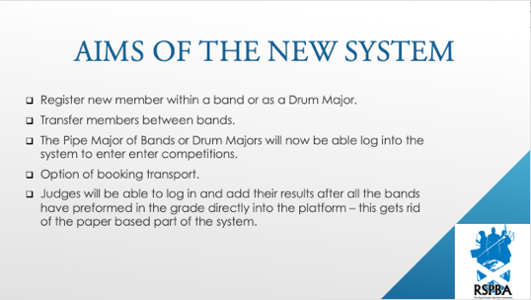inclusive and the central location to handle all of their processing requirements.

The solution would also allow for judges to enter their results onto the system directly after the bands have competed – this in turn would decrease manual processing at the end of each competition before the finale and results – thus speeding up the time between the competition finishing and the finale beginning.

The user interface must be user friendly and of a graphical nature. The interface must be intuitive and concurrently allowing the user to effectively use the program.

In the new completely digital solution, the President would also like to include improved existing features:

* View Results and Judges comments online and give the breakdown of the individual results from each judge and section of the pipe band. The Judges’ sheet should also be made available to bands with their comments about the performance.
* Option of booking transportation – This will be done via an independent bus company and an initial email will be sent from RSPBANI and then the rest of the communication will be done between the company and the client.
* View a list of the competitions with dates and locations and who has entered each competition.
* Guest View where you do not need to log into your account – but only able to view minimal content i.e. just results, competition dates and registered bands for the specific competitions.
* The ability to print and send the results of each competition to all bands alongside each band individually receiving their own judging comments.

A major concern for any new solution is that of data protection with regards to sensitive information that the system must hold about all individuals. This information is required during the sign-up period but specific details about the individual should only be made available to specific groups of people depending on their role within the association.

## Identify and describe, to others, the possible limitations of a solution to the problem.

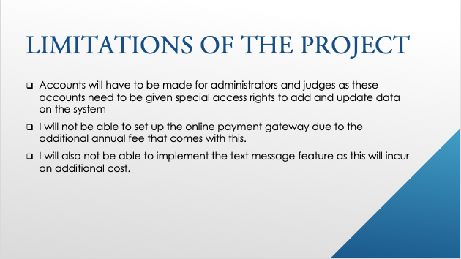**Limitations of the new Solution**

One of the major limitations of the implementing the new system will be time constraints to complete the project and my programming knowledge.

They payment of the entrance fee for all bands and drum majors will be a limitation of the project as I will not be able implement a payment gateway for credit or debit card transactions. Instead I plan to send an invoice via email at a later stage, which may not happen in this development due to the strict time frame.

I will not be able to implement my software over the internet as hosting my project as website on the internet or as packaged mobile application due to the additional cost of a domain name and the programming ability to implement my app online so that is has the ability to retrieve updated data respectively.

Another limitation of the project will be sending the PM of the Band a text message as a confirmation for entering a specific competition as this will incur a cost. As this is coursework and I will have a limited time to complete it, I am not sure whether I will be able to implement all functionality, I may decide to leave the solo competitions and drum majors out of the new system and completely focus on the pipe band side of competitions. The other features I have mentioned can be developed in a later build.

## Consider and use feedback from others to refine understanding of the problem and proposed solution.

*Figure 1.3.1*

*****Figure 1.3.2*

Figure 1.3.3

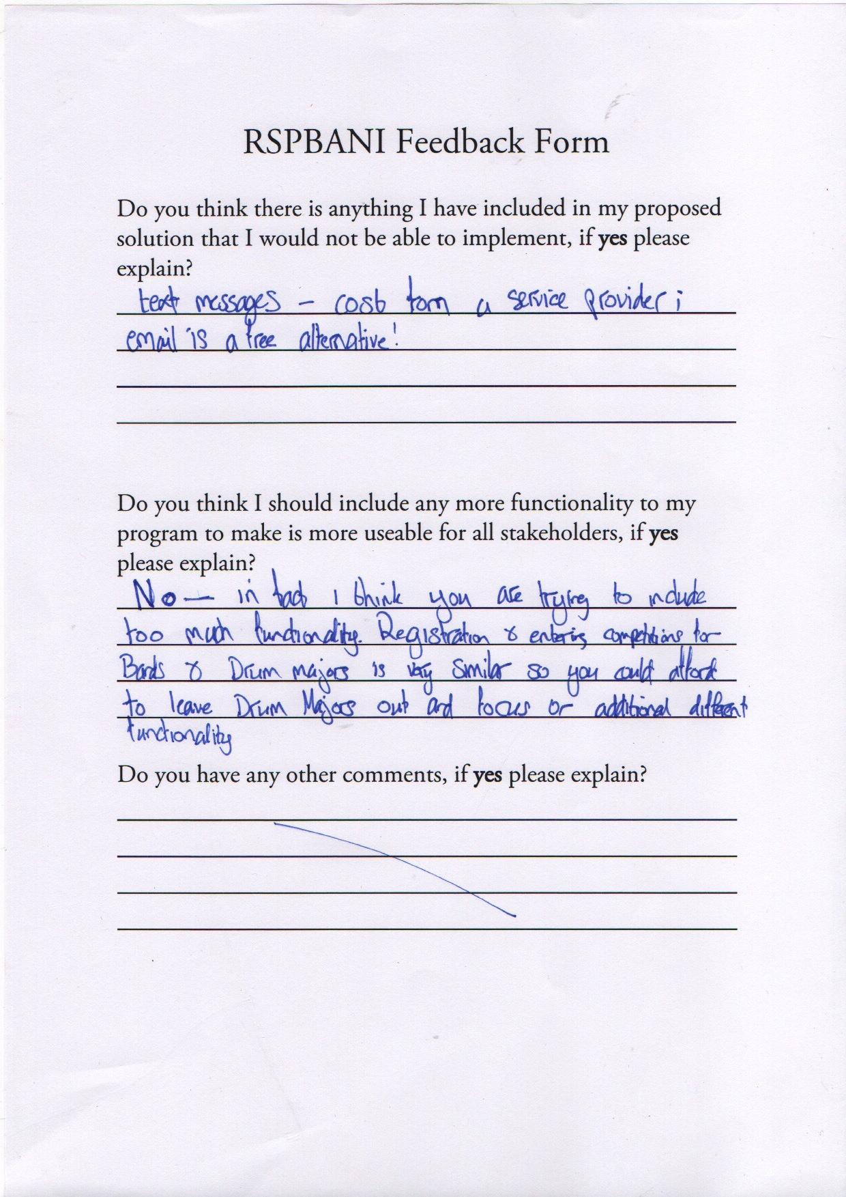

**Feedback Evaluation**

I have carefully considered all the feedback from my peers and competent third parties and have included my reasoning to why I have chosen to implement their feedback or not.

|  |  |  |  |
| --- | --- | --- | --- |
| Feedback Point | Outcome from feedback & reasoning | Implications of implementing feedback | How will it affect Design and development? |
| Instead of the texting facility; email can be used as an alternative | Yes, I have chosen to go ahead with this amendment as it should be easier to implement, and it is also a free service | An email account will need to be created to send the emails from on behalf of the association | I will need to ask for email addresses instead of mobile numbers as a method of contact. |
| Search for any member to see their band or role | I will not be implementing this feature, at least not for the Guest View as this breaks the RSPBANI policy with regards to supply/release of members names to the public. |  |  |
| A news feed/updates section | I don’t think I will go ahead this idea not because I don’t like it but because they include that functionality on their Facebook page – whereas they want this system more centralised around bands and competitions. |  |  |
| Too much similar functionality with regards to PM & DM registration and competition entrance. | I agree this this feedback. I will reduce the functionality by removing Drum Majors and soloists from the new system due to the time frame I have. Although this feature can easily be implemented as it is very similar to the Band processes, I will implement. | Very little implications are the PM & DM registration/entering do not affect each other as they would have run parallel. | This will make the development shorter but will not be removing any functionality as it will be already covered |

Other comments from feedback:

|  |  |
| --- | --- |
| Question | Answer |
| Will the judge’s sheets be electronic for use during a competition or paper based? | All the judges will have access to the system on an electronic device where they can comment and grade as they go along to make the process more efficient and easier for all clients. |
| How will you link members to a band? | To Register a member to a band, the band must be logged into the system. When a member is registered, they will be registered to the band that is logged in and there will be a relationship between every member in the band with the band when the data is stored in the system. |